EC Bios and Main Bios
Main Bios is connected/ Communicate with PCH
EC Bios is connected/communicate with IO
Firmware /sequence EC Bios me store hota hai and communication krta hai IO ke sath, then IO PCH ko deta hai data
EC Bios Power ON krne ke liye ke liye kaam krta hai.
Power ON hone se pehle EC Bios Kaam krta hai…
Power ON hone ke bad Main Bios kaam krta hai

Pin no 3, 7, 8 should have 3.3 volt then program bios
Hold# - no hold until no voltage, 3.3 volt then hold

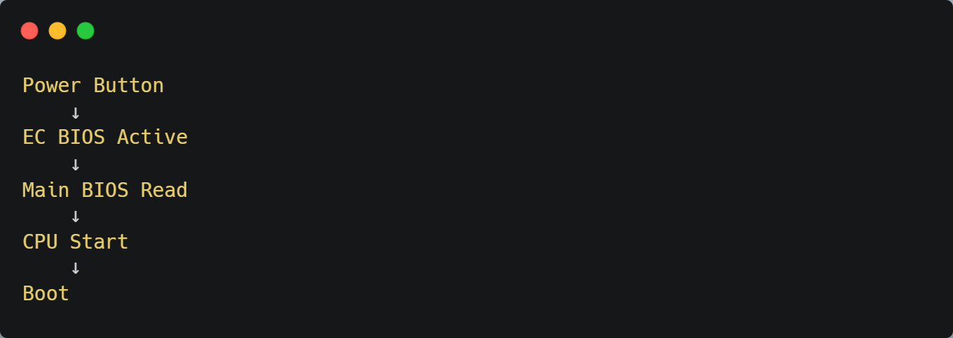

EC = Switch on karta hai
Main BIOS = System load karta hai

Kab EC Flash Karna?
Agar:
- Power bilkul dead
- Power button work nahi
- Charging LED nahi
Tab EC corrupt hota hai.
Note:
Bios vcc 3v, 1.8v(new laptop)

